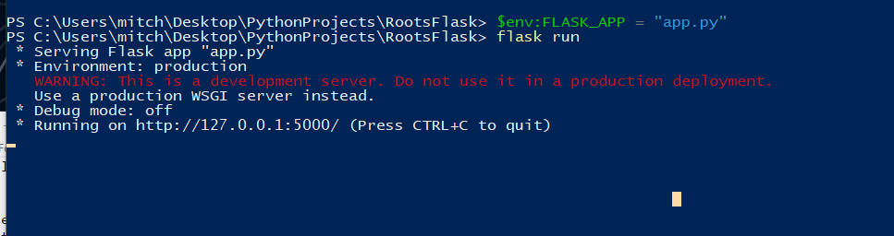
set the env: FLASK_APP env ahead of time. (can automate by making a powershell script

